Resource sheet 1i:

Strategic planning for volunteer involvement – checklist

1. We have identified why we want to involve volunteers (tick as many as apply):
- To benefit from skills and/or experience that are currently lacking
- To expand the local profile of the organisation
- To provide credibility to our organisation
- To support and enhance the work of paid staff
- To expand the organisation’s activities
- Event management and support
- To help improve service users’ quality of life
- As a way of being involved with one’s local community
- Volunteers are the group or organisation.

2. We have prepared for involving volunteers in the following ways:
You should be able to tick all of these. For help answering the last two statements, complete the Resources and budgeting planner

- We understand how involving volunteers relates to the mission and objectives of our organisation
- We have thought about how we can make volunteering with our organisation attractive to prospective volunteers
- We have planned how to address any issues relating to how attitudes and beliefs in our organisation might affect how employees and volunteers relate to each other
- We have consulted with existing staff and involved them in planning
- We have addressed any staff concerns about involving volunteers
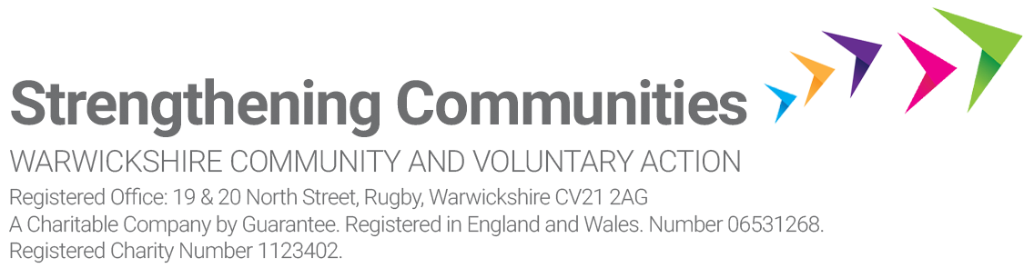
- We have taken into account all of the costs involved in involving volunteers
- We have obtained the necessary tools and equipment for volunteers to carry out their roles safely and competently.

3. We consider our volunteer programme could help individuals to (tick as many as apply):
- Gain new skills and experience
- Benefit from the ‘feel good’ factor
- Do something that they believe in
- Meet people and make new friends
- Occupy their time
- Enhance employability
- Contribute something of wider benefit
- Gain a reference
- Build confidence.

For more information

National Council for Voluntary Organisations (NCVO)
NCVO champions the voluntary sector and volunteering across Britain by connecting, representing and supporting voluntary organisations. It has a reputation as an authoritative voice for the sector.

- www.ncvo.org.uk Phone: 020 7713 6161 Email: ncvo@ncvo.org.uk

NCVO Knowhow Nonprofit
Knowledge and e-learning for charities, social enterprises and community groups. Learn from experts and peers, and share your experiences.

- www.knowhownonprofit.org

DISCLAIMER
Although every effort has been made to verify the accuracy of materials in CAVA's resource
library, users are advised to check independently on matters of specific interest.

